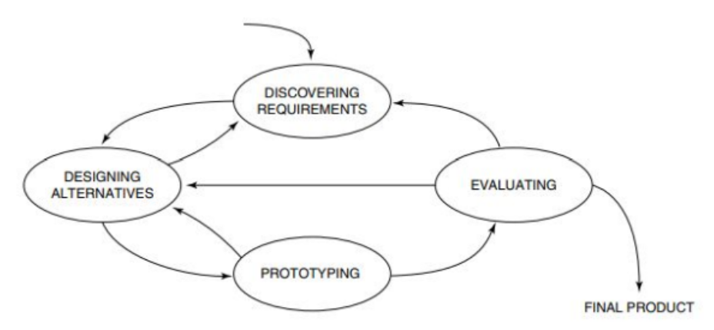

The design process. Source: interaction design: beyond human-computer interaction.